Who is Martin J. H. Povser?

When I decided to make this into a book, I wanted to convey not only what handwriting analysis is but to take your hand and show you what an analyst does, especially what he endures. Some segments of the public don’t think much of us. We are charlatans and fortune tellers, practicing mystical nonsense, so they say. I did want to find an analyst who has been through both the professional bruises and the pats on their back in the handwriting jungle. But I wanted someone who was close by. After considering this standard, I reluctantly decided the analyst I should cover was me. There are many good and competent analysts with wide experience. They were just too far away from me. I didn’t relish writing about me. I wanted to write about someone else, observing what they have gone through, partly to see if our experiences were similar. I didn’t want this to turn into a personal memoir or an autobiography. Believe it or not, I don’t like telling about myself and, as you will read in the book, I am somewhat self−conscious. People like us don’t want to create a fuss about ourselves. We despair when we cause a scene. We don’t like attracting attention. I writing about me was not easy or fun.
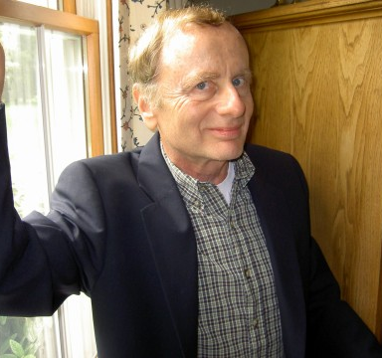
In addition, although I wanted to write a book, I didn’t consider myself a very good writer. I had plenty of experience in the law doing briefs and pleadings in straightforward, dreary verbiage. Besides, most of the book isn’t about the personal trials of an analyst. It’s about the subject of handwriting analysis. Thus, its format in the third person was appropriate. Making it in the third person all the way through gave it consistency. That comforts readers and re−assures editors. As a small test, I also wanted to see how objective I could be writing as an eyewitness to an analyst being an analyst.
Enter Martin Povser, a personage from the crevices of my mind. He would be this other being to relieve me of all these woes. I was calling on him to write the book. Now I would be calmer with his talking about my moments on the firing line. I could avoid having to talk about me. Writing in the third person, Povser wouldn’t be self−conscious either. He was somebody different, who was not afflicted as I was. I could mold him without any drawbacks I might have and with no reluctance to talk about who I was and what I go through. Since I also wasn’t that great a writer, I told Povser he was to be the writer and to get working on learning the craft so the book would at least be presentable. He did, reading several books on how to be a good writer and constantly re−writing drafts until the latest one was, as they say, abandoned to the publisher.
Photo of Martin Povser, fka Allan K. Grim, Jr.

Some people would call Martin Povser my alter ego. I don’t know about that. What has happened to me personally is that the whole experience of writing this book has transformed Allan Grim into Martin Povser. I guess that’s good. It makes me a better person. I’m less self−conscious and a better writer, with a wider perspective on what analysts undergo with the skeptical public. The third−person format of Povser talking about Grim has led me to more objectively evaluate my handwriting thoughts and actions. Hope you enjoy reading what he says about me and the topic of handwriting analysis.

